**Steps to access e-resources via OpenAthens remotely:**

Step 1: Search the OpenAthens web page

Step 2: Clicking the link <https://www.openathens.net/>

Step 3: After open the link page click Login to MyAthens

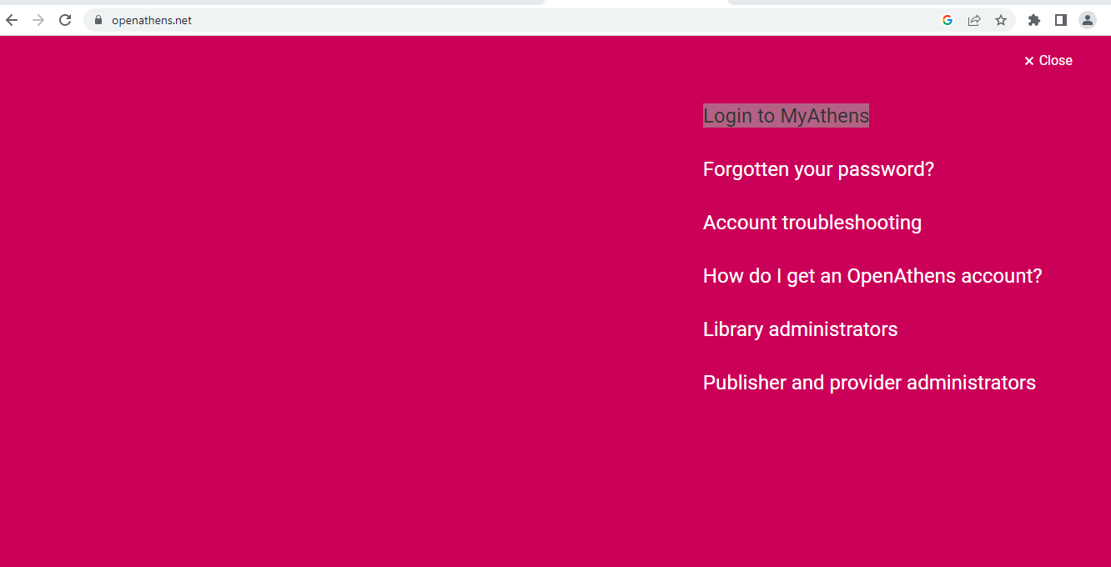

Step 4: After Login to MyAthens we have search college name **(i.e Manipal Tata Medical College)**

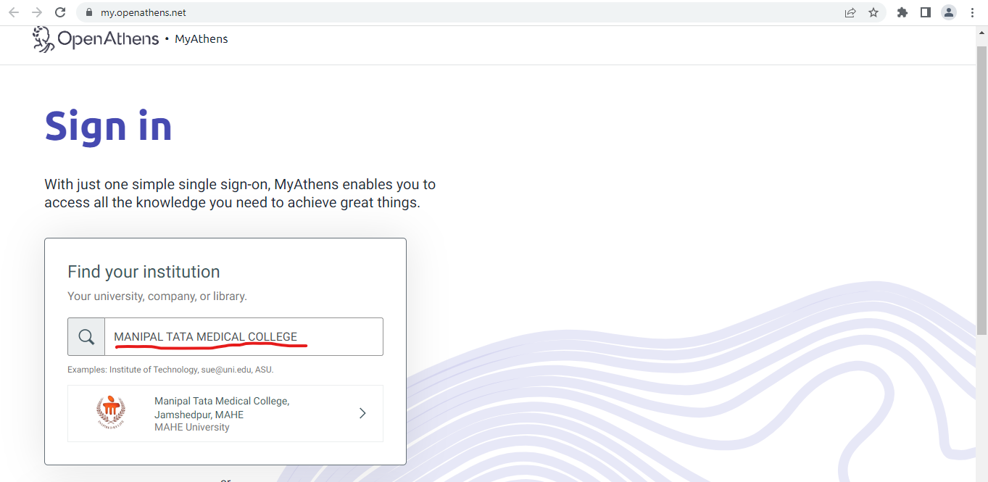

Step 5: The page directly links to manipal.edu login credentials after clicking the Manipal Tata Medical College. The faculty shall login through manipal mail id. Username and password 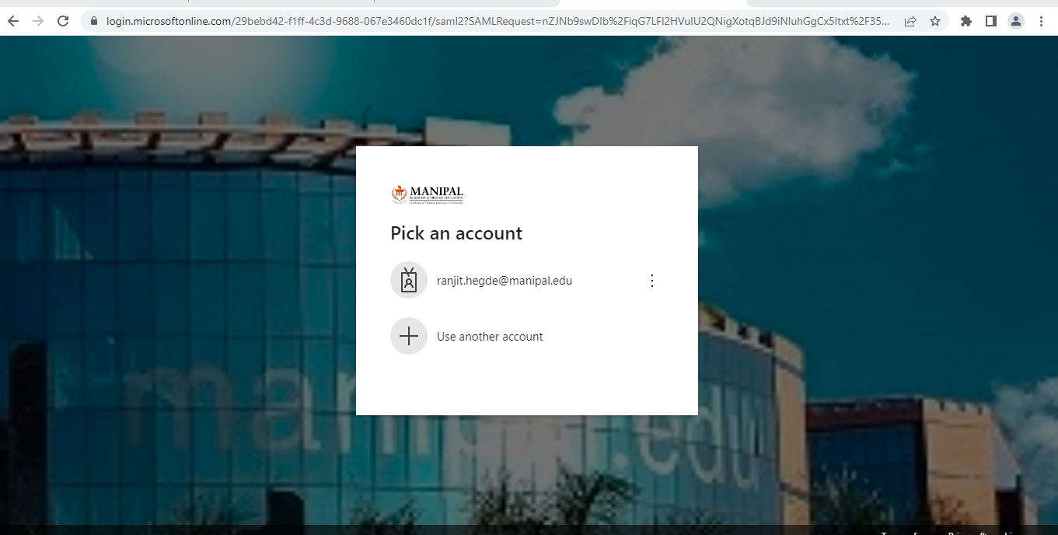

Step 6: After adding the manipal username and password the mail verify your identity using any four options. The options mentioned below.

1) Approve a request on my Microsoft Authenticator app (**For this option users have to download Microsoft Authenticator app in mobile)**

2) Use a verification Message Code **(A six-digit message code will come to register mobile number)**

3) Call to register mobile number **(From +1855-330-8653 call will come. After receiving the call next user has press #(hash) button)**

4) Use a verification SMS Code **(For this option A six-digit SMS code will come to register mobile number)**

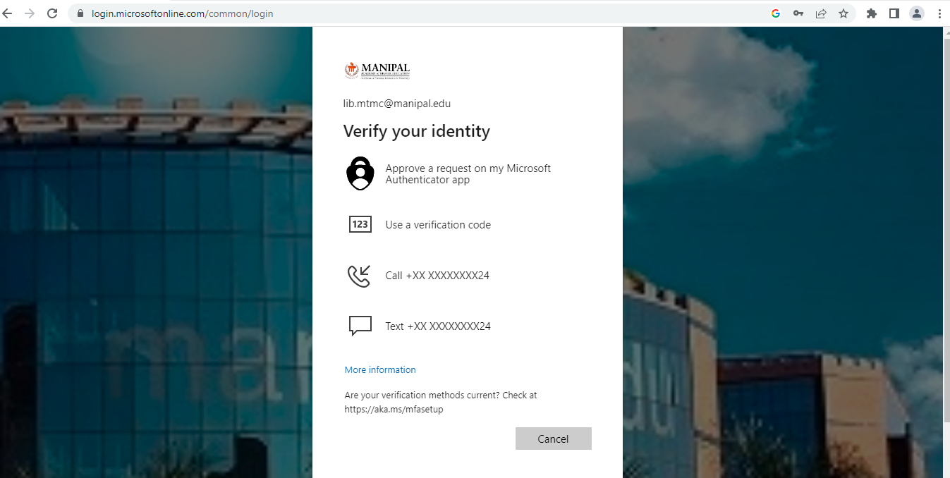

Step 7: Following your approval of the email with your manipal.edu credentials. The Manipal Tata Medical College Open Athens home page will be open. The databases offered by MAHE Institution Access, which are listed below, can be searched.

1. Journal Citation Reports (JCR)
2. Web of Science
3. SpringerLink
4. Taylor & Francis Online
5. Wiley Online Library
6. BMJ Journals
7. Elsevier (Science Direct)

